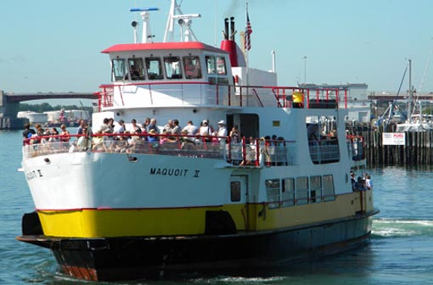

  

Please join us as we load a charter bus and make our way to Bailey Island. Once we get there, we’ll hop aboard for a relaxing afternoon cruise on the waters of this part of the scenic Maine Coast. We’ll cruise past lighthouses, forts and 19th-century summer colonies, Potts Harbor, past Eagle Island and Haskell Island with a peek at Mackerel Cove. I can’t think of a better way to spend a beautiful hot Summer afternoon. We will have 2 pickup places – one at Windham Town Hall and the other at Gray Park & Ride.

**Depart:** Windham @ 10:00am

Gray Park & Ride @ 10:15

**Return:** 3:15 pm Gray Park & Ride

3:30 pm Windham Town Hall

**Cost :** $50.00 (bus and cruise)

** *Please pack a lunch*

**Cruise Bailey Island**  - Monday July 29

*with Windham, Gray and New Gloucester Parks & Recreation Departments*